
An-Najah National University

Movie Rental Data Warehouse Design
From OLTP Schema to Dimensional Model and ETL Design
Based on the Sakila Sample Database
Course: Data Warehousing
Tools: MySQL 8.0, Python (pandas), MySQL Workbench
Submitted by:
Abdalluh Rajab
Aws Thafer
Fadi Omar
Instructor:
Dr. Moamen Abu Ghazaleh

1. Introduction
This report presents a Data Warehouse design for a movie rental business based on the Sakila OLTP database schema. The Sakila database is widely used as a sample for learning database concepts. It represents a realistic movie rental business with customers, films, rentals, payments, inventory, stores, and staff.
The OLTP system supports daily operational activities such as registering customers, managing films, recording rentals, processing payments, and maintaining store information. While the OLTP database is suitable for handling many small transactions quickly, it is not optimized for analytical reporting. Business managers need a different kind of database to analyze rental trends, revenue patterns, customer behavior, and store performance.
This project proposes a Data Warehouse called movie_rental_dw that reorganizes the same business data around analysis rather than transactions. The design follows dimensional modeling principles. The result is a Star Schema with three fact tables and eight dimension tables. The implementation includes the schema in MySQL, an ETL process written in Python using the pandas library, and SQL queries that answer analytical business questions.

1.1 OLTP vs Data Warehouse
The OLTP database and the Data Warehouse serve different purposes. The main differences are:
• Main purpose: OLTP runs daily operations; Data Warehouse supports analytical reporting.
• Schema type: OLTP is normalized (3NF); Data Warehouse is denormalized (Star Schema).
• Workload: OLTP handles many short transactions; Data Warehouse handles few complex analytical queries.
• Data scope: OLTP stores current operational data; Data Warehouse stores both current and historical data.
• Typical users: OLTP is used by cashiers and applications; Data Warehouse is used by managers and analysts.
• Query optimization: OLTP is optimized for fast lookups by ID; Data Warehouse is optimized for fast aggregations across many rows.

1.2 Project Scope
This project covers the following work:
• Identifying analytical business questions that the warehouse should answer.
• Designing three fact tables and eight dimension tables.
• Defining the grain and measures of each fact table.
• Creating a dimensional model diagram.
• Implementing the ETL process in Python using pandas.
• Writing SQL scripts to create the Data Warehouse and load it with data.
• Defining data quality rules for the ETL process.
• Writing analytical SQL queries that answer the business questions.

2. Business Questions
Before designing the Data Warehouse, the analytical questions the business needs to answer must be identified. The structure of the fact tables, the dimensions, and the measures all follow from these questions. The following questions were selected because they cover the main areas of analysis for a movie rental business.

2.1 Film-Related Questions
Q1. Which films are rented most frequently?
This helps the business identify popular films and make better stocking and inventory decisions.
Q2. Which films generate the highest revenue?
This helps managers know which films are most profitable. A film may be rented less often but produce more revenue per rental.
Q3. Which film categories are most popular?
This helps the company understand customer preferences and decide which categories of films to expand.
Q4. Which film categories generate the highest revenue?
This helps the business compare categories based on income, not only on rental count.

2.2 Store-Related Questions
Q5. Which stores generate the highest number of rentals?
This helps compare store activity and identify the busiest stores.
Q6. Which stores generate the highest revenue?
This helps managers evaluate store performance based on financial results.
Q7. How does store performance differ by location?
This helps managers compare stores based on city or country.

2.3 Customer-Related Questions
Q8. Which customers rent the most films?
This helps identify active customers and can support loyalty programs or special offers.
Q9. Which customers generate the highest revenue?
This helps identify the most valuable customers for the business.
Q10. What are the most active customer locations?
This supports marketing decisions and possible business expansion.

2.4 Time-Based Questions
Q11. How does rental activity change over time?
This helps managers understand trends by day, month, quarter, or year.
Q12. How does revenue change by month, quarter, or year?
This helps the business study financial trends and compare revenue across different time periods.

2.5 Staff-Related Questions
Q13. Which staff members process the highest number of rentals?
This helps evaluate staff activity and workload.
Q14. Which staff members process the highest payment revenue?
This helps understand staff contribution to payment processing.

2.6 Return-Related Questions
Q15. Which films are returned late most often?
This helps identify films or customer behaviors related to late returns.
Q16. What is the average rental duration for different films or categories?
This helps the business understand how long customers typically keep different types of films.

These questions are answered using SQL queries in the file sql/analysis_queries.sql. The queries were executed against the loaded warehouse and produce meaningful results.

3. Dimensional Model Design
The proposed Data Warehouse is designed using dimensional modeling principles. The purpose is not to copy the OLTP schema, but to reorganize the same data into a structure that is more suitable for analysis. The selected design is a Star Schema because it is simple, clear, and suitable for answering business questions about rentals, payments, customers, films, stores, and returns.

3.1 Selected Business Processes
Three main business processes were selected from the OLTP movie rental system:
1. Film Rental Process. Each rental transaction made by a customer. It helps analyze rental activity, film popularity, and customer behavior.
2. Payment Process. Each payment made by a customer. It helps analyze revenue, customer spending, store revenue, and staff performance over time.
3. Return Process. Each returned rental transaction. It helps analyze return behavior, rental duration, late returns, and films that are returned late most often.

These three processes were chosen because they represent the most important measurable events in the business. Each one becomes a separate fact table in the Data Warehouse.

3.2 Fact Tables
The Data Warehouse includes three fact tables: fact_rental, fact_payment, and fact_return. Each fact table stores measurable business events and connects to several dimension tables that describe each event.

3.2.1 fact_rental
• Business Process: Film rental transactions.
• Grain: One row for each rental transaction.
• Primary Key: rental_fact_key.
• Foreign Keys: date_key, customer_key, film_key, store_key, staff_key, location_key.
• Measure: rental_count.
• Source OLTP Tables: rental, inventory, film, customer, store, staff, address, city, country.
• Purpose: Helps answer questions about film popularity, rental activity, customer behavior, store performance, and staff activity.

3.2.2 fact_payment
• Business Process: Payment transactions.
• Grain: One row for each payment transaction.
• Primary Key: payment_fact_key.
• Foreign Keys: date_key, customer_key, film_key, store_key, staff_key, location_key.
• Measures: payment_amount, payment_count.
• Source OLTP Tables: payment, rental, customer, staff, inventory, film, store, address, city, country.
• Purpose: Helps answer questions about revenue, customer spending, store revenue, staff performance, and revenue trends over time.

3.2.3 fact_return
• Business Process: Returned rental transactions.
• Grain: One row for each returned rental.
• Primary Key: return_fact_key.
• Foreign Keys: date_key, customer_key, film_key, store_key, staff_key, location_key.
• Measures: return_count, rental_duration_days, late_return_flag, late_days.
• Source OLTP Tables: rental, inventory, film, customer, store, staff, address, city, country.
• Purpose: Helps answer questions about return behavior, average rental duration, and late returns. Only rentals with a return_date are included. In the loaded data, 183 rentals are excluded because they have not yet been returned.

3.3 Dimension Tables
The Data Warehouse contains eight dimension tables. Each dimension is built from one or more OLTP tables. Most dimensions are shared between the three fact tables, which is called a conformed dimension. The eight dimensions are:

Dimension 1: dim_date
• Attributes: date_key, full_date, day_number, month_number, month_name, quarter_number, year_number, day_of_week.
• Source: Generated from rental_date, return_date, and payment_date.
• Purpose: Supports analysis by day, month, quarter, and year.

Dimension 2: dim_customer
• Attributes: customer_key, customer_id, customer_full_name, email, active_status, create_date, city, country.
• Source OLTP Tables: customer, address, city, country.
• Purpose: Helps analyze customer behavior, activity, and revenue.

Dimension 3: dim_film
• Attributes: film_key, film_id, title, release_year, rental_duration, rental_rate, length, replacement_cost, rating, category_key, language_key.
• Source OLTP Tables: film, film_category.
• Purpose: Helps analyze film popularity, revenue, rental duration, and film characteristics.

Dimension 4: dim_category
• Attributes: category_key, category_id, category_name.
• Source OLTP Tables: category.
• Purpose: Helps analyze rental activity and revenue by film category.

Dimension 5: dim_language
• Attributes: language_key, language_id, language_name.
• Source OLTP Tables: language.
• Purpose: Helps analyze films and rentals by language.

Dimension 6: dim_store
• Attributes: store_key, store_id, store_address, city, country.
• Source OLTP Tables: store, address, city, country.
• Purpose: Helps compare store performance based on rentals and revenue.

Dimension 7: dim_staff
• Attributes: staff_key, staff_id, staff_full_name, email, active_status, store_id.
• Source OLTP Tables: staff.
• Purpose: Helps analyze staff performance in rental and payment processing.

Dimension 8: dim_location
• Attributes: location_key, address, district, city, country, postal_code, phone.
• Source OLTP Tables: address, city, country.
• Purpose: Supports location-based analysis.

3.3.1 Shared (Conformed) Dimensions
Most dimensions are shared between the three fact tables, which makes them conformed dimensions. This ensures that analysis of rentals, payments, and returns produces consistent results when filtering by the same customer, film, store, or date.
The dim_date dimension is used three times through three different keys: rental_date_key in fact_rental, payment_date_key in fact_payment, and return_date_key in fact_return. This is called a role-playing dimension because the same physical table plays different roles depending on which key references it.

3.4 Schema Type and Justification
The proposed design uses a Star Schema. In this schema, the three fact tables are placed at the center and the dimension tables are connected around them. There is one minor exception: dim_film references dim_category and dim_language, which adds a small level of normalization on the film side. This is a small snowflake step that keeps category and language reusable as their own dimensions for category-only and language-only analyses.
The Star Schema is appropriate for this assignment because it is simple to understand and supports fast analytical queries. The design does not copy all OLTP tables directly. Instead, related OLTP tables are combined into meaningful dimensions. For example, customer information is joined with address, city, and country to form dim_customer. This reduces the number of joins required and makes the Data Warehouse easier to use for reporting.

4. Dimensional Model Diagram
The diagram below shows the dimensional model of the proposed Data Warehouse. The three fact tables (fact_rental, fact_payment, and fact_return) are placed in the center. The eight dimension tables are connected to the fact tables through foreign key relationships.

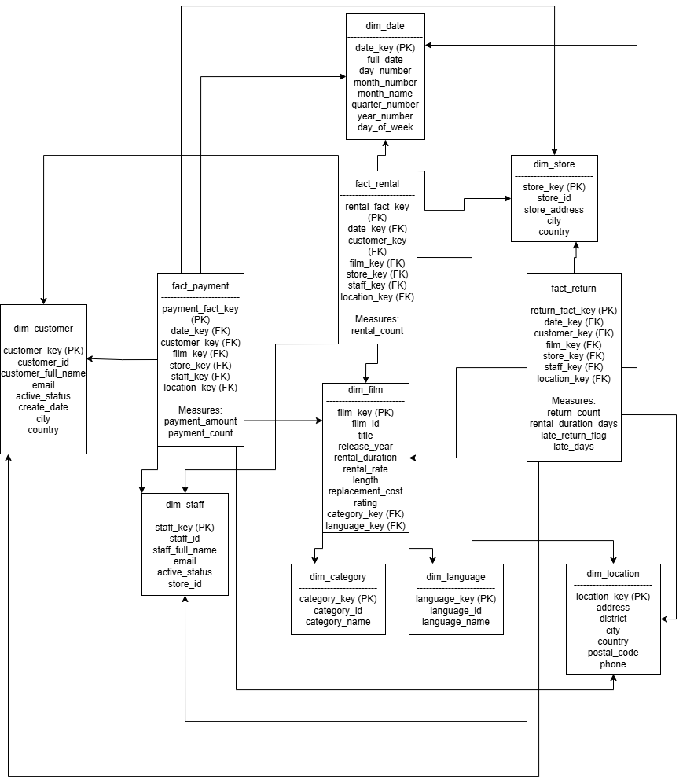
Figure 1: Dimensional model diagram for movie_rental_dw

In the diagram, PK indicates the primary key and FK indicates a foreign key. Each fact table is connected to the dimensions that describe its events. For example, fact_rental is connected to dim_date, dim_customer, dim_film, dim_store, dim_staff, and dim_location.
The model is centered on the three fact tables that represent the main business processes: rentals, payments, and returns. The dimensions are shared between fact tables wherever possible. For instance, dim_customer is used by all three fact tables, which makes it a conformed dimension. dim_film also acts as a conformed dimension and it links to dim_category and dim_language for category-based and language-based analysis.

5. ETL Design
ETL stands for Extract, Transform, and Load. It is the process used to move data from the OLTP system into the Data Warehouse. In this project, the ETL was implemented in Python using the pandas library. The script reads tables from the Sakila OLTP database, applies the required transformations, and writes the result into the movie_rental_dw Data Warehouse. The full implementation is in the file etl_pandas.py.
Python with pandas was used because pandas provides convenient functions for joining, cleaning, and transforming tabular data. The SQLAlchemy library is used with pymysql to connect to MySQL for both the source and target databases.

5.1 Extract
In the Extract step, data is read from the source OLTP tables in the Sakila database. The function load_table reads each table into a pandas DataFrame using a simple SELECT * query. The following OLTP tables are extracted:
• rental: Source of rental transactions; used to build fact_rental and fact_return.
• payment: Source of payment transactions; used to build fact_payment.
• customer: Used to build dim_customer.
• film: Used to build dim_film.
• inventory: Connects rentals to films and stores.
• store: Used to build dim_store.
• staff: Used to build dim_staff.
• address, city, country: Used to build dim_location and join location to customers, stores, and staff.
• category, film_category: Used to build dim_category and assign a category to each film.
• language: Used to build dim_language.

The actor and film_actor tables are not currently extracted because the analytical questions do not require actor-level analysis. They can be added later if needed.

5.2 Transform
In the Transform step, the extracted OLTP data is cleaned, combined, and reshaped to match the dimensional model. Each transformation is implemented as a separate Python function in etl_pandas.py. The main transformations are:

Joining Related OLTP Tables
Several dimensions are built by joining multiple OLTP tables. For example, dim_customer is built by joining customer with address, city, and country. dim_store and dim_location use a similar approach. In pandas, this is done using the merge function with the appropriate join keys.

Creating Full Names
Customer and staff names are stored in the OLTP as separate first_name and last_name columns. In the warehouse, they are combined into a single customer_full_name and staff_full_name column using string concatenation in pandas.

Creating Surrogate Keys
Each dimension uses a surrogate key as its primary key. In this implementation, the surrogate key is derived from the OLTP id (for example, customer_key = customer_id). The OLTP id is also kept as a business key for traceability.

Creating Date Keys
Date keys are integers in the YYYYMMDD format. For example, May 24, 2005 becomes 20050524. This is done in pandas using pd.to_datetime() followed by strftime('%Y%m%d') and casting to int. The dim_date table is generated from the union of all rental dates, return dates, and payment dates, after removing duplicates and missing values.

Calculating Measures
Several measures are calculated during transformation:
• rental_count and payment_count are set to 1 per row, so they become additive when aggregated.
• payment_amount is cleaned by converting empty strings to NaN and then to 0, so the column is fully numeric.
• rental_duration_days is calculated as the difference in days between return_date and rental_date.
• late_return_flag is set to 1 when the actual duration is greater than the expected duration from the film table; otherwise it is 0.
• late_days is calculated as max(actual duration minus expected duration, 0), so on-time returns get 0 instead of a negative value.

Handling Missing Return Dates
Some rentals in the OLTP have a NULL return_date because the film has not yet been returned. These rentals are excluded from fact_return using df.dropna(subset=['return_date']). This is why fact_return has 15,861 rows while fact_rental has 16,044 rows. The difference of 183 rows is the number of rentals not yet returned.

Cleaning Invalid Data
Defensive cleaning is applied to columns that may contain missing or invalid values. For example, the payment amount column is cleaned using df['amount'].replace('', np.nan), followed by pd.to_numeric(errors='coerce') and fillna(0). This makes sure that revenue calculations never fail on bad data.

Handling Many-to-Many Relationships
The film-to-category relationship is many-to-many in the OLTP through the film_category bridge table. In the Sakila data, every film has exactly one category, so the relationship is treated as one-to-many in the warehouse. Each film in dim_film has a single category_key.

Standardizing Text Values
Active status is converted from numeric flags (0 or 1) to text values (Inactive or Active) using np.where. This makes the values easier to read in reports.

5.3 Load
In the Load step, the transformed pandas DataFrames are written into the Data Warehouse using the to_sql function. The load_to_dw helper function handles this for each table, appending rows in chunks of 1000.
Before loading, the function clear_dw_tables runs TRUNCATE TABLE on every Data Warehouse table, with foreign key checks temporarily disabled. This makes the ETL idempotent, meaning it can be run any number of times and always produces the same final result.
The order of loading is important. Dimensions must be loaded before facts because fact tables have foreign keys to dimension tables. The script uses the following order:
1. dim_date
2. dim_customer
3. dim_category
4. dim_language
5. dim_film (depends on dim_category and dim_language)
6. dim_store
7. dim_staff
8. dim_location
9. fact_rental (depends on all dimensions)
10. fact_payment (depends on all dimensions)
11. fact_return (depends on all dimensions)

After running the ETL, the warehouse contains the expected row counts:
• fact_rental: 16,044 rows.
• fact_payment: 16,044 rows.
• fact_return: 15,861 rows.
• dim_date: 90 rows.
• dim_customer: 599 rows.
• dim_film: 1,000 rows.
• dim_category: 16 rows.
• dim_language: 6 rows.
• dim_store: 2 rows.
• dim_staff: 2 rows.
• dim_location: 603 rows.

6. Data Quality Considerations
Data quality is an important part of the ETL process because the Data Warehouse will be used for reporting and decision-making. If the data is incomplete, duplicated, or inconsistent, the resulting reports may mislead managers. A set of data quality rules was identified for this project. Most of them are applied directly in the pandas ETL code.

6.1 Data Quality Rules

Rule 1: Check for missing values
Important fields such as customer_id, film_id, rental_date, payment_date, and payment_amount should not be missing. The ETL handles missing payment amounts by converting them to 0 using pd.to_numeric(errors='coerce').fillna(0). Missing return dates are handled separately by excluding those rows from fact_return.

Rule 2: Check for duplicate records
The ETL uses drop_duplicates on the date dimension to make sure the same date is not loaded twice. dim_film also applies drop_duplicates on film_key to handle any potential duplication from the film_category join.

Rule 3: Validate payment amounts
Payment amounts must be valid numeric values and should not be negative. The ETL coerces invalid strings to NaN and replaces them with 0. In a production system, negative amounts would be routed to an error table for review.

Rule 4: Validate rental and return dates
The return date should not be earlier than the rental date. This is handled by the rental_duration_days calculation. If the difference is negative, the late_days clamp to 0 ensures the measure stays valid.

Rule 5: Handle missing return dates correctly
A missing return date means the film has not been returned yet. These records are excluded from fact_return but kept in fact_rental, so rental activity is still tracked.

Rule 6: Validate foreign key relationships
Every rental, payment, and return record must reference valid surrogate keys in the dimension tables. Foreign key constraints in create_tables.sql enforce this at the database level.

Rule 7: Standardize text values
Active status is converted from numeric 0/1 to descriptive text (Active/Inactive). This prevents confusion in reports.

Rule 8: Check late return calculations
The late_return_flag should be 1 if and only if the actual rental duration exceeds the expected duration from the film table. The ETL implements this using np.where.

Rule 9: Check date dimension completeness
The dim_date table is built from the union of all rental, return, and payment dates. After loading, every fact row should find a matching date_key in dim_date.

Rule 10: Maintain consistency between fact and dimension tables
Fact tables always use surrogate keys that exist in dimensions. The load order (dimensions first, then facts) ensures referential integrity.

6.2 How Quality Is Maintained
Most of the rules above are enforced during the Transform step. The ETL code is written defensively, using pandas and NumPy functions that handle missing or invalid values without failing. Foreign key constraints in the schema also enforce referential integrity at the database level.
In a production environment, additional checks would be implemented as a separate validation script that runs after each load. Failures would be logged and alerts would be sent to the data engineering team. Applying these rules helps make the Data Warehouse more accurate, reliable, and useful for business analysis.

7. Conclusion
This project presented a Data Warehouse design for a movie rental business based on the Sakila OLTP database. The OLTP system is useful for daily operations such as recording rentals, payments, and returns, but it is not optimized for analytical reporting. To support business analysis, the same data was reorganized into a dimensional model called movie_rental_dw.
The final design uses a Star Schema with three fact tables and eight dimension tables:
• Fact tables: fact_rental (16,044 rows), fact_payment (16,044 rows), and fact_return (15,861 rows).
• Dimensions: dim_date, dim_customer, dim_film, dim_category, dim_language, dim_store, dim_staff, and dim_location.

Most dimensions are shared between the fact tables, which is called a conformed dimension. This makes the warehouse consistent when comparing rental, payment, and return information.
The ETL was implemented in Python using the pandas library. The script reads the OLTP tables, applies the required transformations (joining tables, creating full names, generating date keys, computing measures, handling missing values, and standardizing text), and loads the results into the Data Warehouse in the correct order: dimensions first, then facts. The load is idempotent because every table is truncated before being repopulated.
Data quality rules were defined to ensure the warehouse contains accurate and consistent data. These rules cover missing values, duplicates, valid payment amounts, valid date relationships, late return logic, and referential integrity. Most of the rules are applied directly in the pandas ETL code, with foreign key constraints in the schema providing an additional layer of validation.
The proposed Data Warehouse can answer the sixteen business questions identified in Section 2. It supports analysis of film popularity, revenue, customer behavior, store performance, staff performance, location-based trends, time-based trends, and return behavior.
Overall, the proposed Data Warehouse turns operational movie rental data into a structure that is much easier to analyze. This supports better reporting, clearer insights, and more informed business decisions for the movie rental company.

